**MATERIALS SCIENCE & ENGINEERING**

**PROCEDURE IN CASE OF INJURY OR ILLNESS**

**(SUPERVISOR INFORMATION)**

**EMPLOYEE INJURY**

**(Any paid activity including graduate student and undergraduate researchers.)**

* **MEDICAL EMERGENCY** - Call **911** to summons Rural Metro or UT Police at **974-3111** if the accident or illness is serious. An ambulance will be dispatched to transport the worker to a hospital. After 911 contact supervisor.
* NON-EMERGENCY injuries or illnesses the employee must notify their supervisor.
* The employee and supervisor must call UT’s Worker’s Compensation administrator (CorVel) at: **866-245-8588…**The employee and supervisor select the option to speak with a nurse for immediate care. The nurse will direct the employee to a nearby healthcare provider.
* The supervisor shall also call **866-245-8588** and select the option for first notice of loss reporting the day following the accident.
* Supervisor shall call Safety Officer and Dept. Head as soon as possible.

Additional information about Workers Compensation coverage can be found at: [**http://treasury.tn.gov/wc/**](http://treasury.tn.gov/wc/)

The injured/ill employee may be transported by self, co- worker or ambulance.

**STUDENT INJURY**

**(Any class activity by graduate student or undergraduate students.)**

* **MEDICAL EMERGENCY** - Call **911** to summons Rural Metro or UT Police at **974-3111** if the accident is serious. An ambulance will be dispatched to transport the injured student to a hospital. After 911 contact supervisor.
* NON-EMERGENCY injuries or illnesses the student must notify their supervisor.
* The student can be treated at or by:
  1. Student Health

Mon.-Fri., 8AM and 4:30PM

Except Wed., which is 9AM to 4:30PM.

* 1. UT Medical Center Emergency Room.
  2. Their medical provider.

The injured/ill student may be transported by self, acquaintance, or ambulance.

* Supervisor shall call Safety Officer and Dept. Head as soon as possible.
* Supervisor and Student shall complete A Report of Occurrence form. It should be completed and submitted to the Risk Management Office (**865-974-5409**) or [**http://riskmanagement.tennessee.edu**](http://riskmanagement.tennessee.edu/) **and a copy given to MSE office.**

Information on Student Health Insurance **865-974-3135** or the website: [**http://studenthealth.utk.edu/insrec_studentinsurance.php**.](http://studenthealth.utk.edu/insrec_studentinsurance.php)

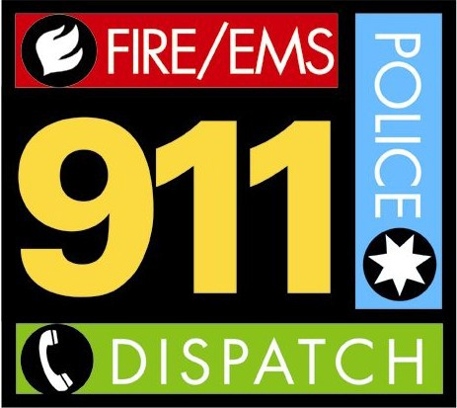

**VISITOR INJURY**

* **MEDICAL EMERGENCY** - Call **911** to summons Rural Metro or UT Police at **974-3111** if the accident or illness is serious. An ambulance will be dispatched to transport the worker to a hospital. After 911 contact supervisor or UT host.
* NON-EMERGENCY injuries or illnesses the individual should notify their UT host and seekcare as directed by their healthcare provider.

The injured/ill visitor may be transported by self, acquaintance, or ambulance.

Notify UT Police **(974-3114)** and Risk Management **(974-5409)**.