Materials Seminar

Department of Materials Science & Engineering

Tuesday October 31, 2017
2:15 – 3:15 ~ SERF 307
Please join us for refreshments at 2:10

" Taking Advantage of Disorder: Small-Molecule Organic Glasses for Radiation Detection and Particle Discrimination "
Speaker:
Dr. Joseph Carlson
Senior Member of Technical Staff
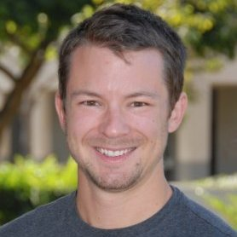
Sandia National Laboratory

Abstract:
As nuclear proliferation by rogue nations grows, so does the need for capabilities that can detect materials for border protection and treaty verification. In the labs of the Radiation Effects & Detection group at Sandia National Labs, Joey Carlson and Patrick Feng have been developing the next generation of materials for radiation detection and analysis. What they have found is a class of highly luminescent molecules that can discriminate between gamma and neutron radiation, rivaling the performance of trans-stilbene single crystals. However, the main technical advantage comes from the ability to easily formulate and melt-cast these compounds into amorphous organic glasses, circumventing many of the problems of single crystals such as cost, fragility and anisotropy.

Biography:
Joseph "Joey" Carlson graduated with a degree in Chemistry from California Polytechnic State University in 2010 after having done research in novel polymer methodology, and internships in natural product synthesis (UC Santa Cruz) and medicinal chemistry (Gilead Sciences). Joey obtained a PhD from UC Irvine under the direction of Chris Vanderwal, his thesis titled "General Approach to the Synthesis of the chlorosulfolipids Danicalipin A, Mytilipin A, and Malhamensilipin A in Enantioenriched Form AND Progress Towards the Synthesis of the Psammaplysin Family of Natural Products". His interest in applied science led to a postdoctoral position at Sandia National Laboratories under the direction of Patrick Feng working on novel organic scintillators. At Sandia Joey discovered and demonstrated the first use of organic glass scintillators that outperformed all of the commercially available benchmarks. Now, as a senior member of the technical staff, Joey continues research into improving organic scintillators for nuclear threat detection

