Materials Seminar

Department of Materials Science & Engineering

Tuesday January 23, 2018
2:15 – 3:15 ~ SERF 307
Please join us for refreshments at 2:10

"Light transport and localization properties of mesoscopic optical disordered media: applications in biological and soft matter systems"

Speaker: Dr. Prabhakar Pradhan
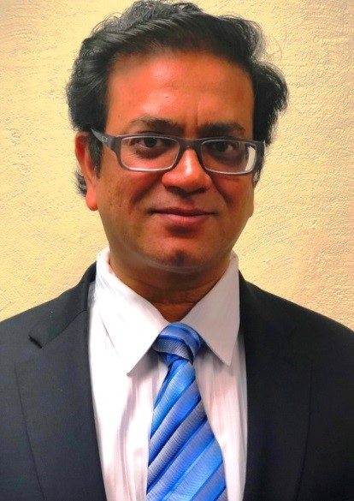
Assistant Professor-Physics & Materials Science
University of Memphis-Memphis, TN

Abstract:
Scientific interest in measuring and quantifying meso- to nanoscopic light transport properties of weakly optical disordered media ranges from dielectric soft condensed matter systems, such as colloids, to biological systems, including cells and tissues. However, conventional optical microscopy cannot probe the weak refractive index fluctuations found, for example, in biological cells, which possess weak scattering properties. Moreover, the diffraction limit cannot be exceeded by standard optical microscopy. Recently, however, we have developed experimental optical spectroscopic techniques that do, in fact, enable us to probe the transport properties of weakly disordered media, such as biological cells, with nanoscale sensitivity beyond the diffraction limit. In this talk, I will first describe the genesis and functions of these novel techniques. Next, I will discuss their practical applications in the study of biological and soft matter systems, including the early-stage detection of cancer by probing and quantifying the nanoscopic light transport properties of single biological cells. Finally, I will discuss how light transport in active disordered optical media can be used to generate micron- to submicron-scale mirrorless lasers and their applications in probing bio/soft matter systems.

Biography:
A Dr. Prabhakar Pradhan is an Assistant Professor in the Department of Physics and Materials Science at the University of Memphis (UofM). Dr. Pradhan did his Ph.D. in Condensed Matter Physics at the Indian Institute of Science (IISc), Bangalore, India. Thereafter, he was a Post-Doctoral Research Associate in the Department of Electrical Engineering at the University of California-Los Angeles, CA, a Research Associate at Dana Research Center, Northeastern University, Boston, MA, and a Visiting Researcher at the Massachusetts Institute of Technology, Cambridge, MA. Subsequently, he moved to Northwestern University, Evanston, IL, where he was a Research Assistant Professor in the Departments of Biomedical Engineering in the Robert R. McCormick School of Engineering and Applied Science, and later joined the faculty at the UofM.

