Materials Seminar

Department of Materials Science & Engineering

Thursday February 22, 2018
3 – 4PM ~ Ferris Hall 414E

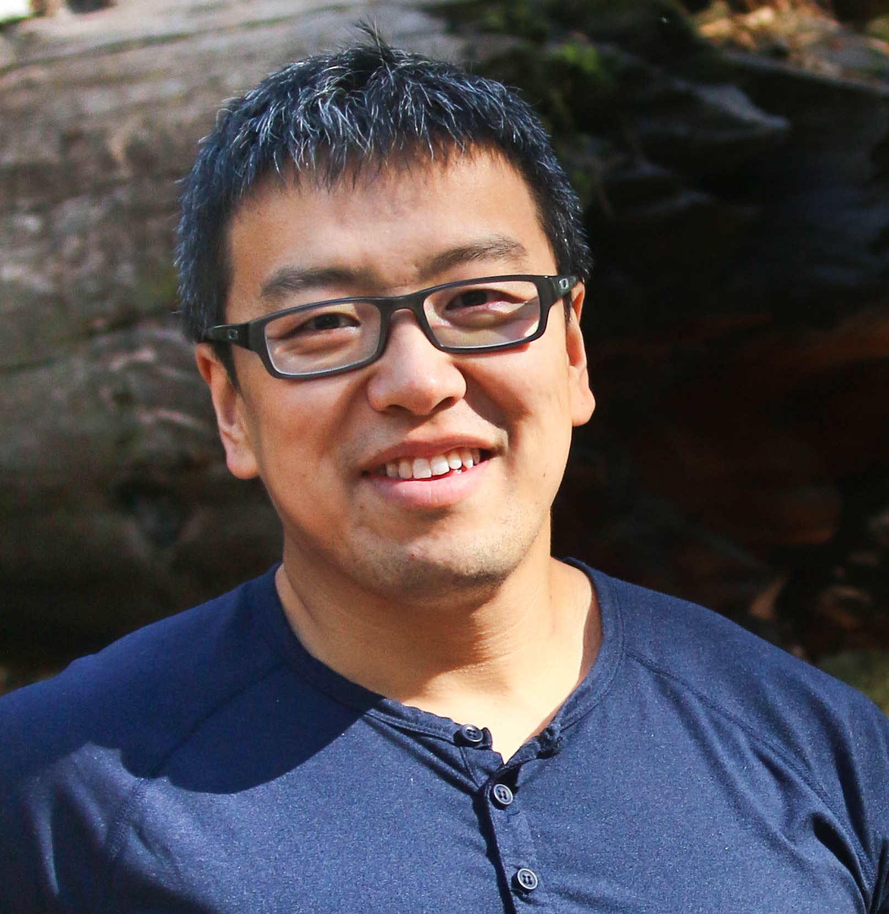
"Reduced Dimension, Extended Opportunities:

2D materials interface controlling and its advanced applications"

Speaker: Dr. Sidong Lei
Postdoc Research Associate & Team Leader
Device Research Lab-University of California Los Angeles

Abstract:
Emerging two-dimensional (2D) materials distinguish themselves from conventional ones by their reduced dimension and dominating surface quantum states. Deep understanding and full utilization of these surface states are essential to the applications of 2D materials in high-performance computing, effective energy harvesting, and better bio-medical technologies. Toward this end, I will introduce our recent breakthroughs in understanding the 2D material surface and interface states, including illustrating their origin and effects on lateral transport; establishing surface modification methods for Fermi level controlling and organic-inorganic hybrid structure construction. I will also discuss our investigation on the vertical quantum tunneling process perpendicular to the 2D lattice, as well as our newest perspectives on the interfacial quantum states. These research achievements can be readily applied to the design and fabrication of advanced integrated electronic and optoelectronic devices, bio-sensors, as well as quantum devices for post-Moore’s Law technologies.

Biography:
Dr. Sidong Lei obtained Ph.D. in Applied Physics from Rice University, Houston, TX in 2015 under the mentorship of Prof. Pulickel M. Ajayan in the Department of Material Science and NanoEngineering. Currently, Dr. Lei is the postdoctoral research associate and the team leader of 2D materials group in Prof. Kang L. Wang’s Device Research Laboratory at the University of California, Los Angeles. Dr. Lei has broad interdisciplinary research interests, with a strong emphasis on novel low-dimensional and quantum material synthesis and characterization, advanced electronics/optoelectronics design and fabrication, 2D surface physics and chemistry, new experimental methods and instruments development.

This Seminar will be followed by Dr. Lei’s vision for future research in MSE 4-4:30. Please join us for refreshments at 4:30

