Materials Seminar

Department of Materials Science & Engineering

Wednesday March 28, 2018
3:30 – 4:30 ~ 307 SERF
Faculty Candidate

"Metallic Microparticles under Extreme Impact Conditions"
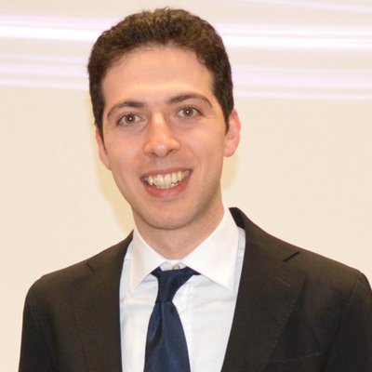

Speaker: Dr. Mostafa Hassani-Gangaraj
Postdoctoral Associate
Department of Materials Science & Engineering
Massachusetts Institute of Technology

Abstract:
When microparticles impact solid materials at high velocities, a variety of extreme-condition phenomena can occur, including bonding, phase transformation, chemical reaction, and erosion. The conditions required to effect these various phenomena are known rather imprecisely because of limitations on experiments designed to study them. This talk will survey my recent work using a new in-situ test methodology to launch, observe, and study microparticle impacts, at micron length-scales and nanosecond timescales. Combining real time observations and post-mortem characterizations with theoretical development and modeling, this talk will provide new insights on materials mechanics and physics at extremes. The talk will review in detail the conditions under which we observe solid-state bonding as well as impact-induced melting. The former provides a basis for solid-state metals additive manufacturing, and the latter opens new opportunities in mechanochemistry.

Biography:
Mostafa Hassani-Gangaraj is a Postdoctoral Associate in the Department of Materials Science and Engineering at MIT. He received his PhD with the highest honors in Mechanical Engineering from Polytechnic University of Milan in 2014. During his PhD, he applied impact to create gradient nanostructures in metallic materials, and enhanced their fatigue performance. In 2015, he joined Prof. Schuh’s group at MIT where his current focus is to fundamentally understand impact-induced extreme conditions in metallic microparticles, and to exploit them is a basis for solid-state additive manufacturing. Mostafa was awarded the Roberto Rocca Postdoctoral Fellowship and the “Nanotechnologies and Nanostructured Innovative Materials” award. His recent results were featured on the MIT News page, as well as eight other news outlets. Invited by the Army Research Laboratory, Mostafa is currently co-editing a book on cold spray additive manufacturing.

