Materials Seminar

Department of Materials Science & Engineering

Tuesday April 10, 2018
2:15 – 3:15 ~ SERF 307
Please join us for refreshments at 2:10

"X-ray Diffraction and the Capabilities of the JIAM Diffraction Facility"

Speaker:
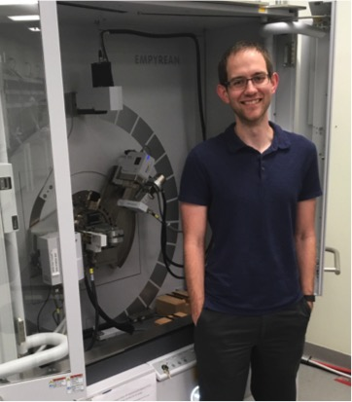
Dr. Michael Koehler
Joint Institute for Advanced Materials
Diffraction Facility - Lab Manager

Abstract:
X-ray diffraction (XRD) is a powerful technique used to study a wide variety of materials. Research into poly- and single-crystal materials, polymers, biological materials, thin films, ion-irradiated materials, and others can greatly benefit from XRD. This seminar will briefly introduce how the atomic structure of a material determines the X-ray diffraction pattern, cover many of the capabilities (e.g. grazing incidence, texture, non-ambient in-situ, phase quantification, etc.) found in the JIAM Diffraction Facility, show examples of the data that can be obtained, and analyze these data utilizing the HighScore Plus software and PDF-4+ database available in the JIAM Diffraction Facility.

Biography:
Michael Koehler received his B.S., M.S., and Ph.D. in Materials Science and Engineering from the University of Tennessee – Knoxville (UTK). Michael obtained his Ph.D. under the direction of Veerle Keppens, in which he utilized resonant ultrasound spectroscopy, capacitance dilatometry, vibrating sample magnetometry, X-ray diffraction, and neutron diffraction in his studies of magnetoelastic materials. Michael then obtained a post-doctoral position at UTK under the direction of David Mandrus, in which he grew 2-dimensional, transition metal dichalcogenide semiconductor crystals with chemical vapor transport. During this time, he also began managing the Tennessee Crystal Center, which licenses these crystals to universities around the world. Michael is the now the lab manager for the Diffraction Facility located at the Joint Institute for Advanced Materials, where he further develops the capabilities of the facility and assists users as they utilize the instruments and analyze their data.

