Materials Seminar

Department of Materials Science & Engineering

Tuesday April 17, 2018
2:15 – 3:15 ~ SERF 307
Please join us for refreshments at 2:10

"Disorder, crystals & the forgotten parts of powder diffraction"

Speaker: Dr. Matt Tucker
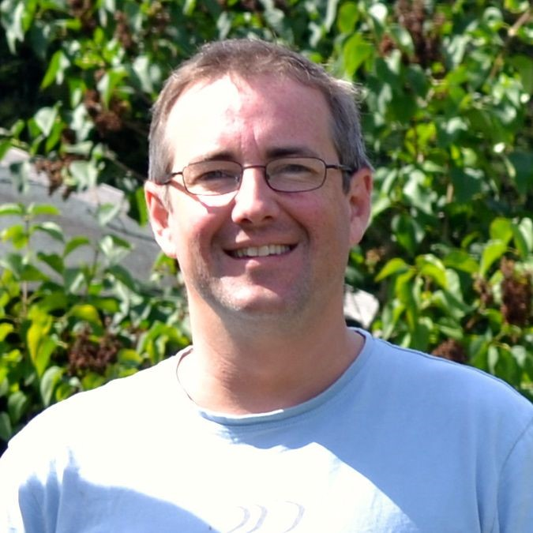
Diffraction Group Leader-Neutron Scattering Division
Oak Ridge National Laboratory-Oak Ridge, TN

Abstract: Many of the useful materials that make modern life possible are crystalline. Quartz keeps our watches on time, perovskites are widely used in consumer electronics and solid oxide fuel cells may help to power the future.
The importance of local structure and disorder in crystalline materials is increasingly being recognised as a key property of many functional materials. From negative thermal expansion to solid state amorphisation and the 'nanoscale' problem to improved fuel cell technology, a clear picture of the local atomic structure is essential to understanding these phenomena and solving the associated problems.
Total scattering, an extension of the powder diffraction method, is increasingly being used to study crystalline materials. The unique combination of Bragg and diffuse scattering can be used to determine both the average structure and the short-range fluctuations from this average within a single experiment. To maximise the structural information from such data, three-dimensional atomic models consistent with all aspects of the data are required.
Here I will give an introduction to a program and technique, RMCProfile[1], that can help you get the most from this valuable data. I will then give several examples to illustrate the sort of useful information you can gain using the total scattering method.
[1] RMCProfile: reverse Monte Carlo for polycrystalline materials M G Tucker, D A Keen, M T Dove, A L Goodwin, Q Hui J. Phys.-Condes. Matter 19 335218 (2007) – also more information and the program available at www.rmcprofile.org.

Biography: Matt joined ORNL in January 2016, where he leads the Diffraction group. This group operates and maintains 9 diffractometers, 4 at HIFR and 5 at the SNS and includes the NOMAD instrument, which specializes in the measurement of the local structure of materials.
Prior to joining the SNS, Matt was a Research Scientist in the Crystallography Group at the ISIS Facility, Rutherford Appleton Laboratory since 2005. Since 2013, he also had a joint appointment at the diamond light source. At ISIS he was an instrument scientist on the high flux medium resolution POLARIS diffractometer, which is a world-class instrument for total scattering measurements. At Diamond he was helping to design, build and ultimately run Europe’s first dedicated X-ray-PDF beamline (XPDF). Previously, he was a PDRA for 6 years in the Department of Earth Science at the University of Cambridge after obtaining his PhD from the University of Kent at Canterbury.
His research interests focus on using and developing total scattering techniques for the study of disordered crystalline materials and is the co-author of over 130 publications. Highlights include studies of negative thermal expansion, pressure induced amorphisation and colossal thermal expansion. He has successfully led the development of a Reverse Monte Carlo program (RMCProfile) specifically for the analysis of total scattering data of polycrystalline materials (with Prof. Martin Dove, Prof. David Keen, Dr Igor Levin and several other contributors). This program suite is freely available for download from www.rmcprofile.org.

