Materials Seminar

Department of Materials Science & Engineering

Tuesday April 24, 2018
2:15 – 3:15 ~ SERF 307
Please join us for refreshments at 2:10

"High Performance Solution-Processed Perovskite Solar Cells via Device Engineering & Novel Materials"

Speaker:
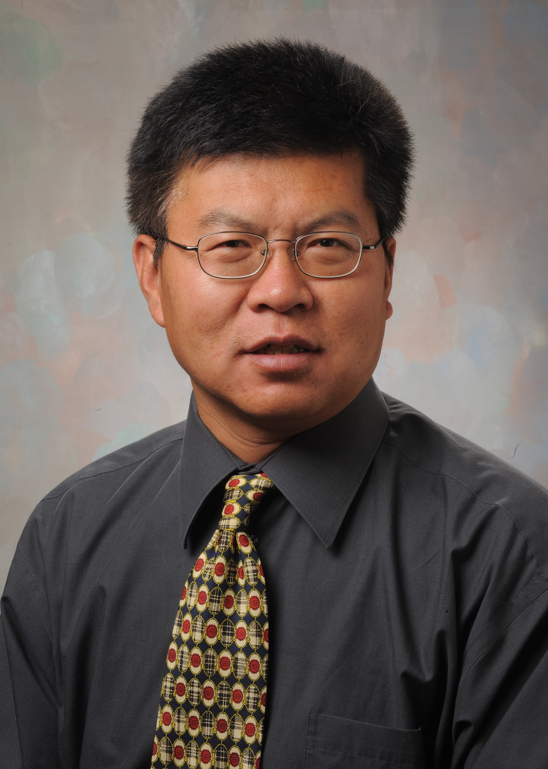

Dr. Xiong Gong-Professor
College of Polymer Science & Engineering
University of Akron, Akron OH

Abstract:
Solution-processed perovskite solar cells for efficiently and economically harvesting the solar energy have invoked extraordinary attentions in both academic and industrial sectors in the past decades. In this presentation, I would like to share with you how we approach high-performance solution-processed perovskite solar cells via device engineering and novel materials.
- Both cross-linkable ionomer and radical polymer as the interfacial layers to modify the interface between the hole/electron extraction layers and perovskite active layer for boosting efficiency of perovskite solar cells have been demonstrated.
- In order to facilitate the electron extraction efficiency and make it comparable to the hole extraction efficiency in perovskite solar cells, we, for the first time, have demonstrated bulk heterojuncion perovskite solar cells with enhanced efficiency and reduced photo-hysteresis.
- In order to balance charge transporting properties, enhance efficiency and stability of perovskite solar cells, we have developed novel perovskite materials incorporated with transition metal cations and rare earth cations for tune its optoelectronic properties. As a result, efficient and stable perovskite solar cells fabricated by these novel perovskite materials are realized.

Biography:
Currently, Dr. Gong is a Professor of Polymer Engineering in the Department of Polymer Engineering of the College of Polymer Science and Polymer Engineering at the University of Akron. Prior that, he was a manager and senior scientist of CBRITE Inc. and senior research scientist in the Center of Polymers and Organic Solids at University of California Santa Barbara. Dr. Gong received B. Sc. major in Chemistry, M. Sc. Major in Chemistry and Ph. D. major in Physics from China. He did his post-doc fellowship with Professor Alan Heeger, a Nobel Prize Laureate, in the Center of Polymers and Organic Solids at University of California Santa Barbara. Dr. has accomplished ~200 articles published in the peer reviewed journals, with a peer citation ~20,000 times. He earned an H-index of 54. He also contributed 29 granted patents and 6 pending patents, and 9 book chapters. Dr. Gong received many international and national awards and honors including named the top 1% mostly cited researchers in the years of 2014, 2015 and 2016, the world's most influential scientific minds 2014 by Thomson Reuters, National Science Foundation (NSF) of USA Career award (2014) and NSF of China oversea outstanding Chinese youngest scientist award (2008).

