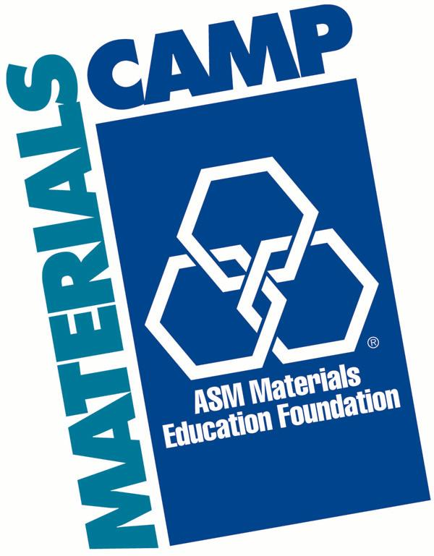 | 2022 MATERIALS CAMPSM  The University of Tennessee, Knoxville  July 11 – 15th, 2022  Presented by:  ASM Materials Educational Foundation  Pellissippi State Community College  Center for Materials Processing  UT Dept. Materials Science & Engineering  UT Materials Advantage Student Chapter

APPLICATION FORM

Part 1
Student’s Name: |  |  |  |  |  |  | Preferred 1st name for name tag:

Address:
 |  |  | Street or P.O. Box |  |  |  | City |  |  |  | State / ZIP Code

E-mail address: *

*Most communication will be done electronically so it is important that we have a current e-mail address to correspond with you.

Citizenship:
Sex: |  | Male Female |  |  |  |  | Age:
Father’s Name: |  |  |  |  |  |  | Mother’s Name:
Address: |  |  |  |  |  |  | Address:
City/State/ZIP: |  |  |  |  |  |  | City/State/ZIP
Telephone |  |  |  |  |  |  | Telephone
 |  |  | Day Evening |  |  |  | Day Evening
Grade you will be entering next fall (2016): |  |  |  |  |  |  | Freshman Sophomore |  |  |  | Junior Senior

Name of current school:

School Address:
 |  |  |  |  | Street |  | City |  |  |  | State /ZIP Code

Title of the highest course for the following subjects:

 | Mathematics: |  |  |  |  | Chemistry:
 | Physics: |  |  |  |  | Other Science Courses:

Part 2
- Attach two (2) letters of recommendation.
- B. Are you related to an ASM member? |  | Yes No
If yes, please provide the name of the ASM member and your relationship.
Member name: |  |  | Re Relationship

C. Why do you want to attend Materials Camp?

- What are your favorite subjects in school?

- What is your planned college major?

- What are your future career plans?

- Add a personal statement (100 words or more).

